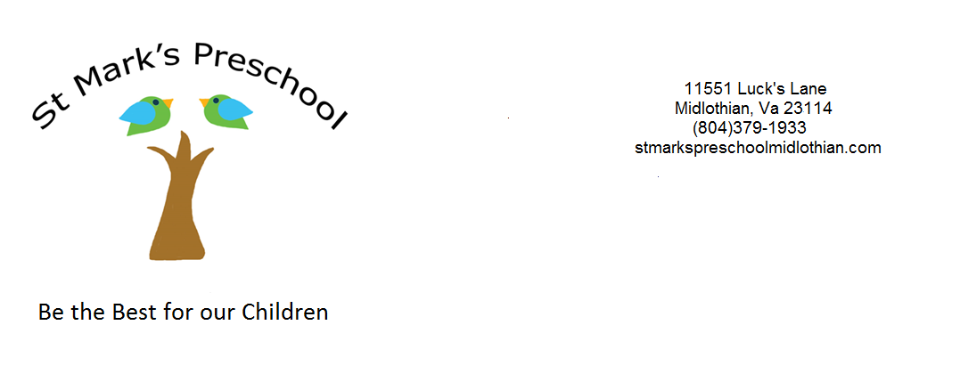Application for Enrollment Pre K and JK classes

Name__________________________________________________________________________

Name your child goes by_______________________________

Gender_________ Age as of September 30, 2022_____________ Birthday _________________

Mother’s Name_______________________________ Father’s Name______________________

Address_______________________________________________________________________

Phone: Home____________________ Mom’s Cell________________________

Dad’s Cell_______________________ (Please circle the phone # to use for an emergency)

Current Student: Yes or No

Church Member: Yes or No

Sibling Previously Enrolled: Yes or No

Please indicate the program in which you wish to enroll your child for 2022-2023 school year

4 YEAR OLD CLASS ( “4” by Sept 30, 2022)

______ 3 Day Class (Monday, Tuesday, Thursday 9:30-12:30) $225.00 mo.

______ 3 Day Class Extended Day (M&W 9:30-2:00; F 9:30-12:30) $255.00 mo.

______ 4 Day Extended Day (M-Th. 9:30-2:00) $330.00

JUNIOR KINDERGARTEN CLASS (“5” by Dec. 31, 2022)

______ 5 Day JK Extended Day (M-Th. 9:30- 2; F 9:30-12:30) $345.00 mo.

**Sibling discounts: 10% off second child, 5% for each additional child**

Primary email address where you would like to be reached (please write clearly)

_____________________________________________________________________________________

Any secondary email address where you can be reached

_____________________________________________________________________________________

Subdivision where child resides___________________________________________________________

Member of St. Mark’s United Methodist Church? Yes or No

Would you like information about St. Mark’s United Methodist Church? Yes or No

Names and locations of all previous attended schools or child care facilities:

_____________________________________________________________________________________

Does your child have an allergy that requires an epi pen or any other medication? ___________________
If so, please list the allergens and describe the reaction:________________________________________

Does your child have any medical conditions that the school should be aware of? _______________________
If so, please explain: _______________________________________________________________________

Any additional information the school should know about your child:_____________________________

_____________________________________________________________________________________

Date of desired enrollment_______________________________________________________________

Registration and Activity Fee

I am enclosing $170.00 ($120.00 registration and $50.00 activity fee) in payment for the registration fee and the activity fee as required by the school. I understand that neither of these fees apply towards your tuition. Only the activity fee would be refundable if notified by August 1, 2022.

September Tuition

September tuition is due by May 15th. If tuition is not received by this date, I understand that my child’s space may be filled from the waiting list.

Withdraw

I understand that if I plan to withdraw my child, I need to give the school a month’s notice or I will be responsible for paying that month’s tuition. Notice needs to be given by August 1st for September tuition to be refunded.

Parent Signature:_________________________________________ Date_________________________

**Explanation of fees** The registration fee holds your child’s place and is used to purchase supplies for your child to start the new year. The activity fee funds enrichment programs that enhance your child’s preschool educational experience.

MEDICAL ALERT: SPECIAL NEEDS CHILDREN

St. Mark’s Preschool is proud to have a tradition of welcoming special needs children. Some children have easily discernible needs, such as hearing aids or leg braces. Recently, children who are seeking enrollment have less visible needs, such as allergies to foods, the environment, or insect bites. Whereas St. Mark’s will do everything possible to create and maintain a safe environment for the students, we are not equipped to handle life-threatening conditions.
For this reason, the St. Mark’s Preschool requests that each parent determine if the normal, routine safety precautions used for every child is sufficient for your child. For example, the classroom teacher may make every effort to comply with dietary requests, but toddlers and older children may “sneak food” or be offered food by another student while the teacher is busy elsewhere. St. Mark’s cannot and will not be responsible for these incidents. Similarly, environmental risks will be monitored to the extent possible, but the general classroom will not be changed to suit the needs of one child to the detriment of others. Therefore, it is up to you, the parent, to decide if your child can safely attend this preschool.
ST. MARK’S PRESCHOOL, INCLUDING INDIVIDUAL STAFF MEMBERS, WILL NOT BE RESPONSIBLE FOR ANY ADVERSE CONSEQUENCE TO YOUR CHILD SO LONG AS THE ORDINARY CARE IS PROVIDED, WHICH IS AVAILABLE TO EACH STUDENT.
Epinephrine will be the only medication we administer.

___________________________________
Parent’s Signature

RELEASE OF INFORMATION

I hereby give my permission for the distribution of my address, email and/or telephone number to other parents of children enrolled in St. Mark’s Preschool. I understand home and email addresses and phone numbers will not be given out for any commercial purposes.

___________________________________
Parent’s Signature

PHOTO RELEASE FORM FOR MINORS
St. Mark’s Preschool
11551 Lucks Lane
Midlothian, VA 23114

I, being the parent/guardian of __________________________________ hereby give consent that the photographs or videos taken of him/her during preschool and while he/she is enrolled at St. Mark’s United Methodist Church Preschool as a student may be used by St. Mark’s United Methodist Church Preschool. These pictures may be used in slideshows, emails, bulletin boards, crafts, preschool brochures, school websites, Preschool Facebook page, etc. When any pictures of students do appear there will not be any personal identification (i.e. student name). Furthermore, I consent that such photographs or videos shall be the property of St. Mark’s United Methodist Church Preschool which has the right to duplicate, reproduce, and make other uses as the preschool deems necessary. I understand these photographs and videos may be taken using the school tablet or by a teacher’s personal cell phone who has undergone a full background check. These will promptly be deleted from the previously mentioned when the use of the photographs have been completed.

____ I give permission to use my son/daughter’s photographs, etc. AS DESCRIBED ABOVE.

____ I DO NOT give my consent to have photographs of my son/daughter used by St. Mark’s United Methodist Church IN ANY WAY, as specified above.

Name of Student: ____________________________________________ DOB: _________________

Signature of Parent: ________________________________________________________________

Street Address: ____________________________________________________________________

City, State, ZIP: _________________________________________ Phone: ____________________

Please sign and return this to the Preschool office. This form will be kept on file in the student’s permanent record in the Preschool office. Parents may update or make changes to this form at any time.

-------------------------------------------------------------------------------------------------------------------------
For office use only: Verification of identity and age - verified by________________________

Document: ______________________ place of birth_______________________________

birth date____________ birth certificate no._________________date of issuance________
(if available)

